Assessment Schedule – 2012

Music: Demonstrate aural understanding through written representation (91275)

Evidence Statement
Question | Achievement | Achievement with Merit | Achievement with Excellence
ONE | Chord Recognition
(a) | There are 11 chords to be identified.  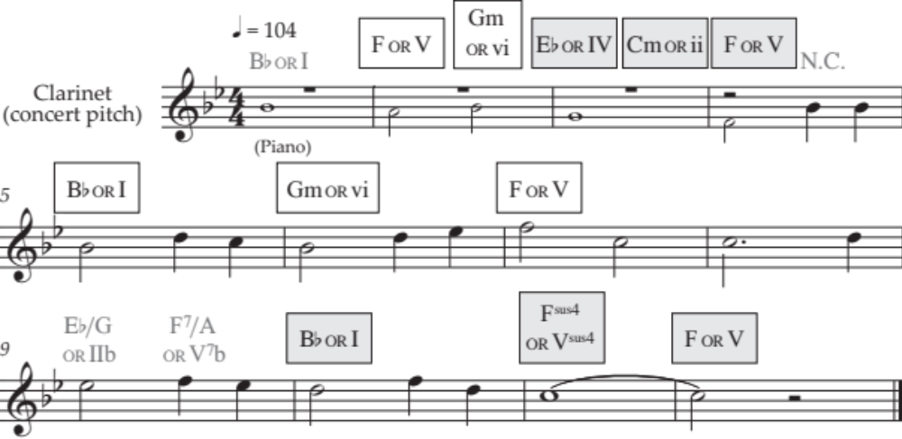  Cadence ①: Imperfect  Cadence ②: Imperfect
(b) | There are 11 chords to be identified.  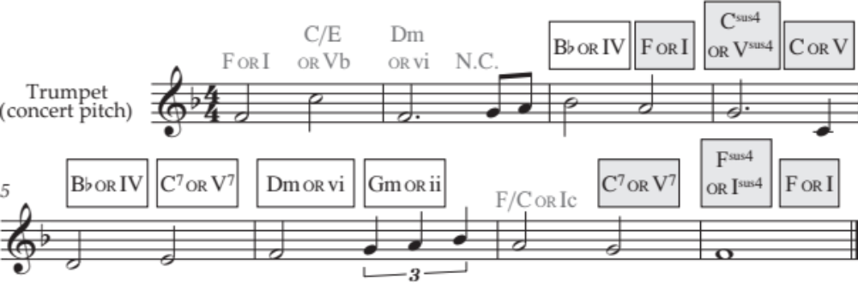  Cadence ①: Imperfect  Cadence ②: Perfect

N1 | N2 | A3 | A4 | M5 | M6 | E7 | E8
Identifies ONE (of 11) chord in isolation in either part of the question. | Identifies TWO (of 11) chords in isolation in either part of the question. | Identifies FOUR (of 11) chords in isolation in either part of the question. | Identifies SIX (of 1) chords in isolation in either part of the question. | Identifies TWO cadences  AND  For ONE cadence, identifies all three highlighted chords. | Identifies THREE cadences  AND  For TWO cadences, identifies all three highlighted chords. | Identifies TWO progressions of FOUR adjacent chords from across both extracts. For this purpose, disregard the “N.C.” in (a). | Identifies THREE progressions of FOUR adjacent chords from across both extracts. For this purpose, disregard the “N.C.” in (a).
N0= No response; no relevant evidence.

Question | Achievement | Achievement with Merit | Achievement with Excellence
TWO | Melodic and Rhythmic Dictation
(a) | There are six contours / patterns, and two phrases to transcribe.  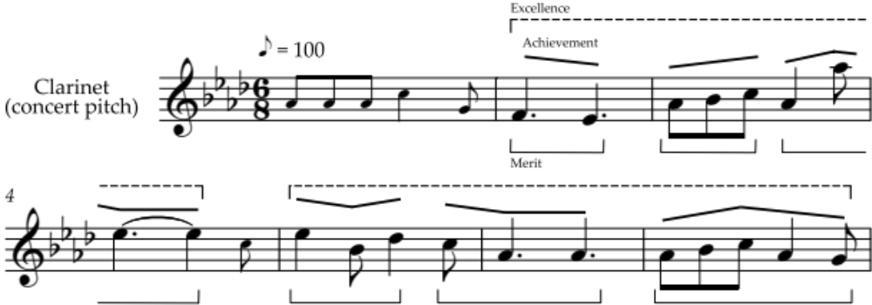
(b) | There are six contours / patterns, and two phrases to transcribe.  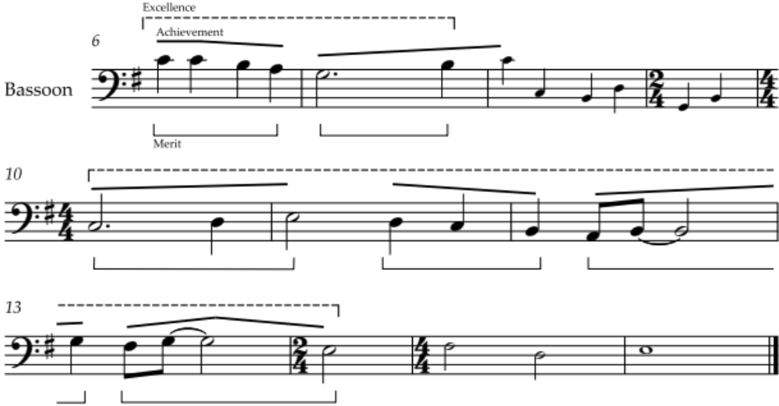
 | Note that accurate identification of a contour requires that its first and last pitches are appropriate in relation to the pitches that precede and follow it.

N1 | N2 | A3 | A4 | M5 | M6 | E7 | E8
Identifies ONE (of 12) contours. | Identifies TWO (of 12) contours. | Identifies THREE (of 12) contours. | Identifies FIVE (of 12) contours. | Accurately transcribes FIVE (of 12) patterns. | Accurately transcribes SEVEN (of 12) patterns. | Transcribes TWO (of four) phrases accurately, with allowance for TWO inexact pitches or rhythms. | Transcribes THREE (of four) phrases accurately, with allowance for TWO inexact pitches or rhythms.
N0= No response; no relevant evidence.

Question | Achievement |  | Achievement with Merit |  | Achievement with Excellence
THREE | Elements and Expressive Features
(a) (i) | Identifies TWO elements / features characteristic of jazz, eg:  - swung rhythm  - call-and-response between instruments and voice  - instrumentation: voice with trumpets, trombones, rhythm section (drums, bass, guitar)  - instrumental (brass) “hits”  - accompaniment keeps a steady four-beat rhythm  - lead vocal “bends” the rhythm  - lead vocal has upward slides at the end of each phrase.
(ii) | Identifies any TWO of the melody or accompanying instruments:  - trombone [melody instrument]  - trumpet  - (double) bass  - drum kit  - (clarinet / saxophone)  (do not accept “piano”).
(iii) |  | Identifies TWO elements / features of the second verse that are different from the first, eg: |  | Describes, with detailed evidence, TWO elements / features of the second verse that are different from the first, eg:
 |  | - male (backing) vocals alternate with female (lead) vocal in v2; only lead vocal in v1 |  | - male (backing) vocals sing first, second, and fourth phrases, and female (lead) vocal sings third phrase in v2; only the lead vocal sings in v1
 |  | - male vocals keep the same steady beat as the accompaniment in v2; female vocal sometimes “bends” the rhythm in v1
 |  | - male vocals do not have “slides” in v2; the female vocal has slides in v1 |  | male vocals do not have “slides” in v2; the female vocal has slides at the ends of phrases in v1
 |  | - no brass “hits” in v2. |  | - the brass “hits” on the 4th / last beat of the bar in v1 are not heard in v2.

Question Three cont’d
Question | Achievement | Achievement with Merit | Achievement with Excellence
(a) (iv) | Identifies the chorus as being based on a (12-bar) blues (progression).
(v) |  | Identifies TWO elements / features of the chorus that are different from the verses, eg: | Describes, with detailed evidence, TWO elements / features of the chorus that are different from the verses, eg:
 |  | - there are more phrases in the chorus than in the verses | - the chorus has a blues structure of three 4-bar phrases; the verses are each structured as two 4-bar phrases
 |  | - the chord structure in the chorus is different from the verses | - The chord structure in the chorus is I, I, I, I, IV, IV, I, I, V, IV, I, I
 |  | - in the melody of the chorus, the second phrase is the same as the first but over different harmonies; in the verses, each phrase has a different melody | - as is common in 12-bar blues, the harmony of the first phrase of melody is entirely chord I, and the same / similar melody of the second phrase consists of two bars of chord IV then two bars of chord I (the vocalist improvises in both phrases, therefore the melody is not repeated exactly)
 |  | - in the chorus, the brass have melodic improvisation; in the verses the brass have rhythmic “hits”. | - in the chorus, the trombone has a call-and-response with the lead vocal, which sounds improvised at the end of each phrase; in the verses the brass “hits” are synchronised, not improvised.

Question Three cont’d
Question | Achievement | Achievement with Merit | Achievement with Excellence
(b) (i) | Identifies, exactly, TWO of the specified features of the extract:  - Metre: triple  - Tempo: andante  - Tonality: major.
(ii) |  | Identifies ONE way that EACH of the specified features is used in the melody, eg: | Describes, with detailed evidence ONE way that EACH of the specified features is used in the melody, eg:
 |  | Instrumentation  - (two) flutes and violins play the melody. | Instrumentation  - (two) flutes and violins share the melody  - the flutes play the melody a third apart.
 |  | Articulation  - mostly legato / smooth / slurred. | Articulation  - when the flutes have the melody it is legato, and when the strings have it, some notes are played staccato.
(iii) |  | Identifies ONE way that the use of TWO of the specified features contrasts with the previous extract, eg: | Describes, with detailed evidence ONE way that the use of TWO of the specified features contrasts with the previous extract, eg:
 |  | Tempo  - slightly slower. | Tempo  - slightly slower, but seems faster as the (string) accompaniment is in quavers instead of crotchets.
 |  | Tonality  - has modulated to the relative minor key. | Tonality  - the extract begins with a minor chord / the first two chords are I and V in (D) minor  - the melody includes an (ascending) harmonic minor scale.
 |  | Melody  - played by a single flute. | Melody  - decorated with ornaments.

N1 | N2 | A3 | A4 | M5 | M6 | E7 | E8
ONE partial piece of evidence at Achievement level. | ONE piece of evidence at Achievement level. | TWO pieces of evidence at Achievement level. | THREE pieces of evidence at Achievement level. | TWO pieces of evidence at Merit level. | THREE pieces of evidence at Merit level. | ONE piece of evidence at Excellence level. | TWO pieces of evidence at Excellence level.
N0= No response; no relevant evidence.

Judgement Statement
 | Not Achieved | Achievement | Achievement  with Merit | Achievement  with Excellence
Score range | 0 – 8 | 9 – 13 | 14 – 18 | 19 – 24

